Project Design Phase-II

Data Flow Diagram & User Stories

|  |  |
| --- | --- |
| Date | 07 NOVEMBER 2022 |
| Team ID | PNT2022TMID08472 |
| Project Name | Project - IOT based safety gadget for child safety monitoring and notification |
| Maximum Marks | 4 Marks |

# Data Flow Diagrams:

IOT based safety gadget for child safety monitoring and notification

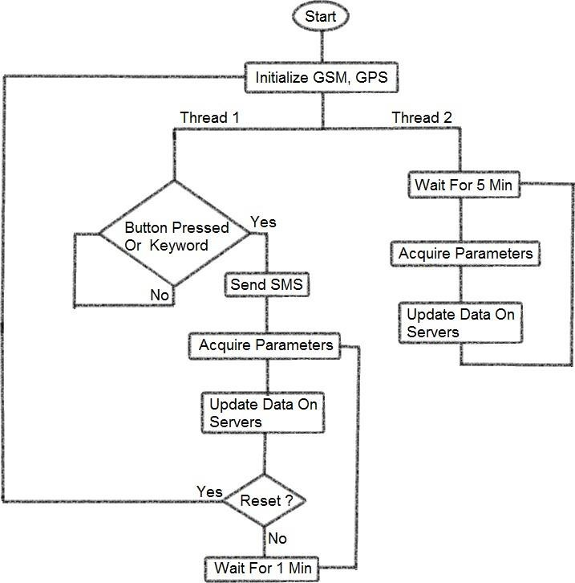

# User Stories

Use the below template to list all the user stories for the product.

|  |  |  |  |  |  |  |
| --- | --- | --- | --- | --- | --- | --- |
| **User Type** | **Functional**  **Requirement (Epic)** | **User Story Number** | **User Story / Task** | **Acceptance criteria** | **Priority** | **Release** |
| Customer (Parents Mobile user) | Registration | USN-1  (Father) | I can access the location of my children using the credentials provided as a Father. | I can access my account / dashboard and receive confirmation email & click confirm | High | Sprint-1 |
|  |  | USN-2  (Mother) | I can access the location of my children using the credentials provided as a Mother. | I can access my account / dashboard and receive confirmation email & click confirm | High | Sprint-1 |
|  |  | USN-3  (Guardian) | I too can monitor the children’s activities using safety gadget monitoring system. | I can access my account / dashboard and receive  confirmation email & click confirm | Medium | Sprint-2 |
|  | Login | USN-4  (if required) | Same function to be performed as in previous cases. | Same function to be  performed as in previous cases. | Not Yet Determined | --------- |
|  | Dashboard | USN-5  (if required) | Same function to be performed as in previous cases. | Same function to be performed as in previous cases. | Not Yet Determined | ----------- |